**# How to Configure RaspberryPI Wifi to access Home wifi network.**

I have use Raspberrypi - 3B model for this settings. I have explained two methods one in GUI and Command Line even the graphic desktop is not loaded. You can execute from CLI.

**Pic 1 :** This model comes with wifi and Ethernet ports , A monitor is directly attached to Raspberrypi device. You can see from Ifconfig Command, that wifi is still open for connection.

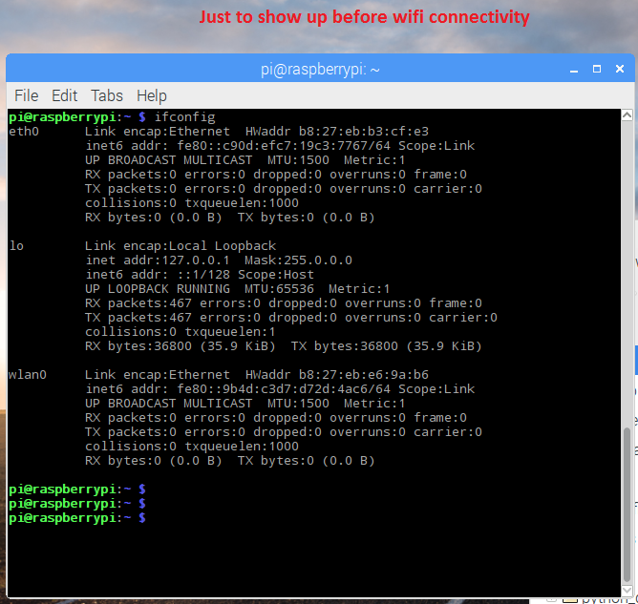

**GUI : Method.**

**Pic2 :** Configure raspberrypi to WIFI,

The GUI method is simple as like our windows / smart phone. Just click the network icon on top right Corner, you will get list wifi networks with SSID’s names, Do select your wifi router name and provide the password Key for connection to establish.

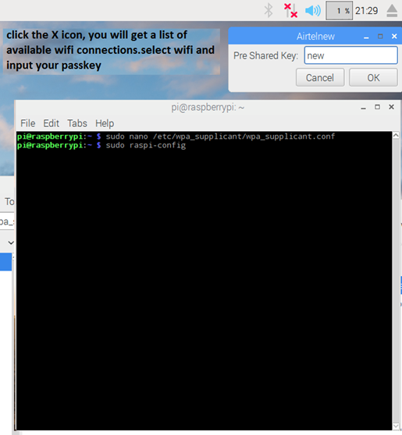

**Pic 3 :** once Password key provided, you connected to your wifi router.

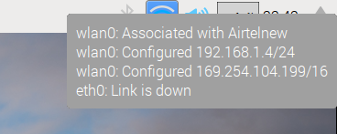

**CLI Mode :**

It is particularly suitable for use with a direct VGA/HDMI cable for raspberrypi console access. Note also that no additional software is required; everything you need is already included on the Raspberry Pi.

**1, Lets configure the hostname, ssh services**

# sudo raspi-config

**Pic 4:** screen shot for raspi-config to run as sudo user.

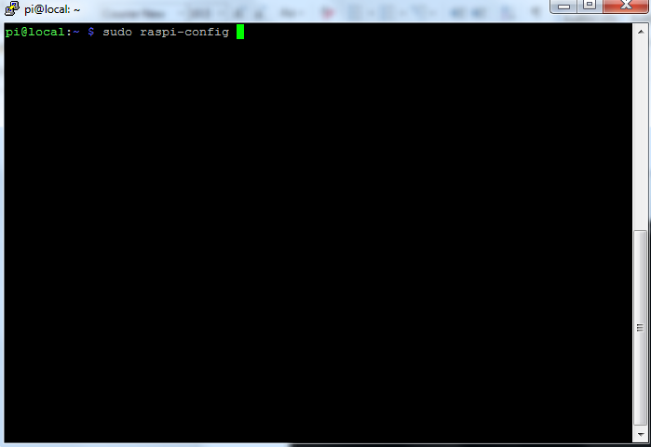

**Pic 5:** You will get menu based windows, I have used this to change Hostname and enable the ssh service so i no need monitor next time to manage the raspberrypi device.

Pic 6: Change Hostname

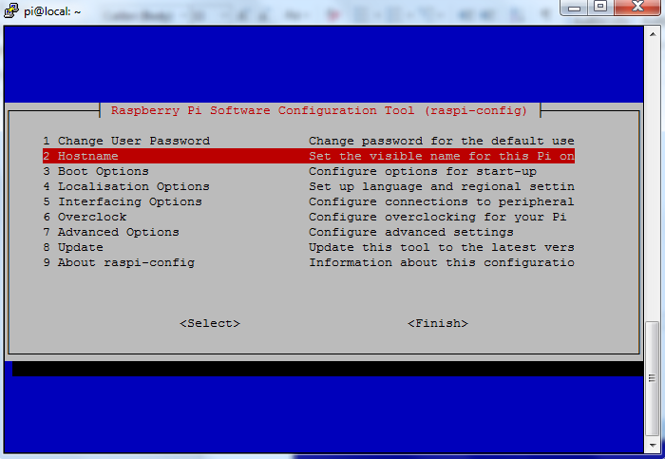

Next Change the Hostname as per your wish. I have done as per the picture below

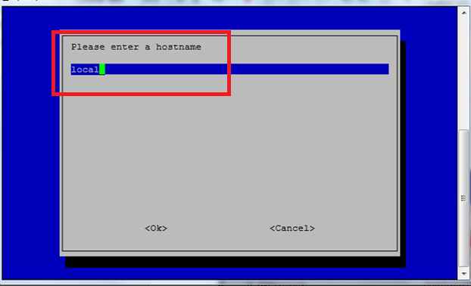

Pic 7: List of option in raspi-conifg, select interfacing option for enable ssh

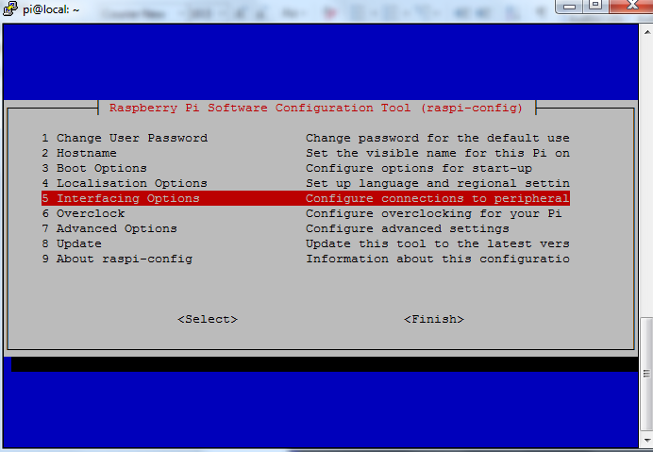

Select option 5 to enable SSH Server if not done earlier.

Pic 8: Enable ssh

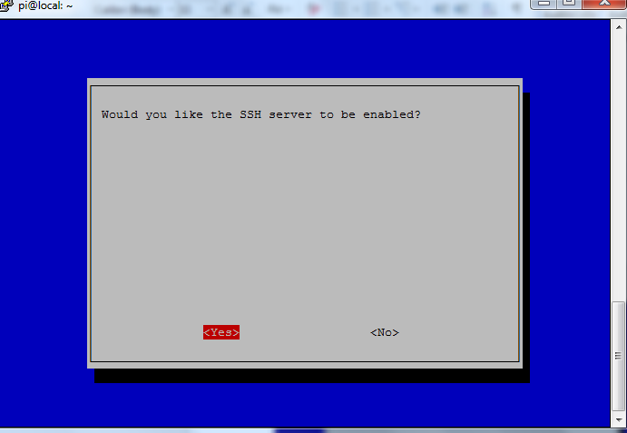

You have reboot to take the changes effect.

**2, Configure wifi networksettings manually by editing the file**

/etc/wpa_supplicant/wpa_supplicant.conf

$ sudo nano /etc/wpa_supplicant/wpa_supplicant.conf

Go to the bottom of the file and add the following:

network={

ssid="Airtelnew"

psk="newpassword"

key_mgmt=WPA-PSK

}

Save and exit file.

**Pic 9:**

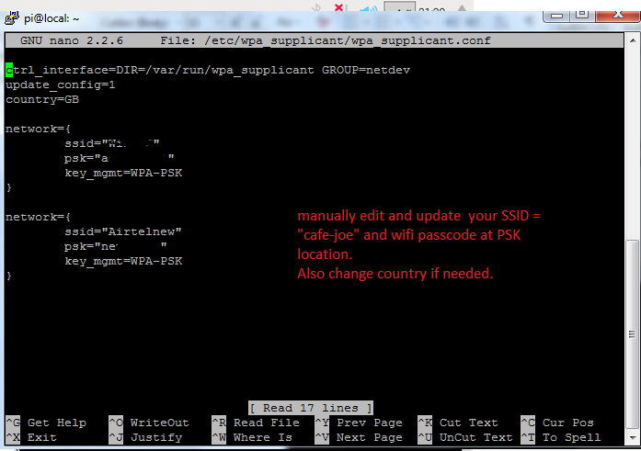

**Pic 10 :** Status showing by wifi bar and and IP get assigned by wifi router.

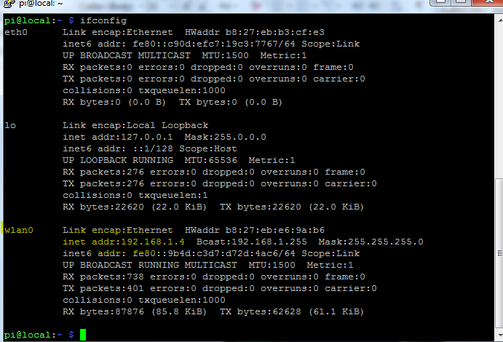

**3, Let access the Raspberry from Chrome in another system.**

**Pic 11 & 12 : web access from out side raspberrypi device**

Open the chrome and input the ipaddress or hostname of raspberrypi. If you configure the dns name in your router, then you can use fqdn at the browser. EX : local.pi.com on your wifi network.

If you can t access it, then you have update your /etc/resolve.conf file.

Example:

# vi /etc/resolv.conf

domain pi.com # Domain Name of local host

nameserver 192.168.1.1 # DNS server IP

nameserver 8.8.4.4

search pi.com # Which Domain to search

**Note :** If you access from internet, then you have set proper DNS entry at your DNS server.

You have reboot to take the changes effect.

